CLeaR Administration Overview for Citizen Developer Landing Zones

Document Status: First Final Draft
Created On: December 09, 2025
Last Updated: December 10, 2025
Contact: ITG Technical Writers, Data + Insights Team, Sergio Pasapera

Contents
1 Overview 2
1.1 Purpose 2
1.2 Scope 2
1.3 Audience 2
2 Governance Roles and Responsibilities (CLeaR Functions) 2
2.1 Eligibility & Training Validation 2
2.2 Agreement Administration 2
2.3 Access Approval & Governance Enforcement 2
2.4 Oversight & Monitoring 2
2.5 Annual Recertification Management 2
2.6 Access Revocation 3
3 Citizen Developer Workflow: End-to-End 3
4 Controls and Compliance 4
4.1 Governance Controls Matrix 4
4.2 RACI Overview 5
5 Summary 5
6 Revisions 6
7 Document History 6
8 Document Control Log 6

Overview

Purpose
CLeaR governs and manages access to Azure Landing Zones (LZs) for Citizen Developers. The team ensures secure, compliant cloud environments that align with firm governance, architecture, and risk standards. It verifies responsibilities before granting access and monitors compliance throughout the lifecycle.

Scope
This guide covers the governance process for Azure Landing Zone access within the Citizen Developer program, including eligibility checks, agreement administration, access approval, monitoring, annual recertification, and decommissioning procedures.

Audience
The document benefits the Data + Insights team, Technology Group, and governance stakeholders overseeing Citizen Developer environments.

Governance Roles and Responsibilities (CLeaR Functions)
This section outlines CLeaR’s key responsibilities in managing the Citizen Developer program.

Eligibility & Training Validation
- Confirm the requester qualifies as a Citizen Developer.
- Ensure the requester completes mandatory cloud, governance, and security training before approval.

Agreement Administration
- Issue the Citizen Developer Agreement for signature.
- Explain responsibilities, restrictions, and consequences for non-compliance.
- Maintain records of all signed agreements.

Access Approval & Governance Enforcement
- Review requests against risk appetite and business justification.
- Approve or decline Landing Zone access based on suitability and risk.
- Coordinate with the Technology Group and provision access once you have obtained approval.

Oversight & Monitoring
- Ensure Landing Zones operate within defined boundaries.
- Request periodic reports on consumption, incidents, and compliance.
- Intervene when risks, misuse, or non-compliance occur.

Annual Recertification Management
- Run the annual recertification process for all Citizen Developers.
- Confirm refresher training, re-sign agreements, and validate ongoing suitability.
- Revoke access for users who fail to recertify or no longer meet the eligibility requirements.

Access Revocation
- Suspend or revoke access for policy breaches, security risks, unmanaged cost overruns, or role changes.
- Trigger internal follow-up processes for severe cases.

Citizen Developer Workflow: End-to-End
Outlined is the end-to-end process for granting and managing Azure Landing Zone access for Citizen Developers:
Step 1: Submit Request:
- The requester submits an LZ access request, including its purpose and justification.
Step 2: CleaR Assessment:
- CLeaR checks eligibility, training completion, and alignment with governance.
Step 3: Sign Agreement:
- The requester signs the Citizen Developer Agreement, acknowledging obligations.
Step 4: Provision Landing Zone:
- The Technology Group provisions the LZ with guardrails, logging, security controls, and policies.
Step 5: Monitor Usage:
- The Citizen Developer works within approved boundaries while CLeaR and Technology monitor compliance.
Step 6: Recertify Annually:
- CLeaR validates suitability and renews agreements yearly.
Step 7: Decommission Landing Zone:
- Technology decommissions the LZ when the use case ends, the user changes their role, recertification expires or fails, or governance or security breaches occur.
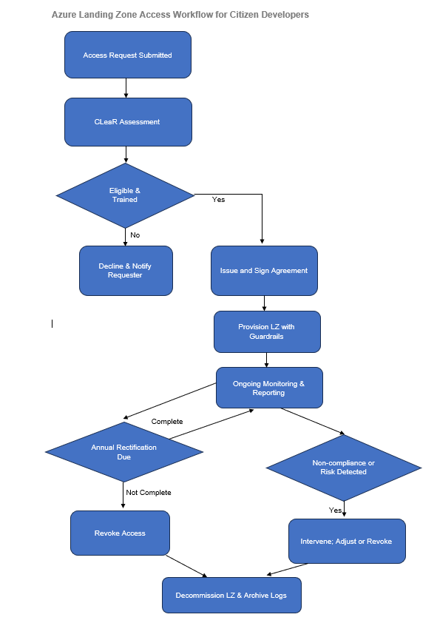

Controls and Compliance

Governance Controls Matrix
Control Area | Owner | Mechanism | Frequency | Triggered Actions
Eligibility & Training | CLeaR | Training verification | On request | Decline if incomplete
Agreement | CLeaR | Signature capture | On approval | Suspend if unsigned
Guardrails | Technology Group | Policy enforcement | Continuous | Block non-compliant resources
Cost Management | Technology Group | Consumption reports | Monthly | Investigate anomalies
Security & Compliance | CLeaR + Technology Group | Alerts & audits | Continuous | Intervene/revoke
Recertification | CLeaR | Annual attestation | Annually | Revoke if not completed
Decommissioning | Technology Group | Deprovision & archival | On trigger | Archive logs, update records

RACI Overview
Activity | CLeaR | Technology Group | Citizen Developer | Security/Architecture
Eligibility & Training | R | C | A | C
Agreement Administration | R | I | A | C
Access Approval | R | C | I | C
Provisioning | I | R | I | C
Monitoring & Reporting | R | R | A | R
Intervention | R | C | I | R
Recertification | R | I | A | C
Revocation & Decommission | R | R | I | R
Legend: R = Responsible, A = Accountable, C = Consulted, I = Informed.

Summary
CleaR ensures secure and compliant cloud innovation by:
- Granting access only to qualified individuals.
- Monitoring usage and enforcing governance.
- Managing recertification and revocation.
- Supporting alignment across Technology, Security, and Architecture.
CLeaR’s oversight protects the Firm’s cloud environments from risk and cost overruns while enabling innovation.

Revisions
The Data + Insights and Technical Writing teams review, test, and periodically revise this document as risks, systems, and business practices evolve.

Document History
Title | CLeaR Administration Overview for Citizen Developer Landing Zones
Version | 0.1
Classification | Internal
Creation Date | December 09, 2025
Last Review Date | December 10, 2025
Author | Suresh Narasimhan
Custodian | Data + Insights team
Document Number

Document Control Log
Version | Change Description | Created by | Reviewed/Approved by | Date of Creation
0.1 | Created the first draft | Suresh Narasimhan | Priya Bhatia | December 09, 2025
0.1 | Completed an end-to-end review of the draft, restructuring and substantially rebuilding it from the ground up | Priya Bhatia | Edmun Benyamin | December 10, 2025

